Build Instructions for Robot Control Module

Using an ESP-32 processor and L293D motor driver chips

# 

# Design:

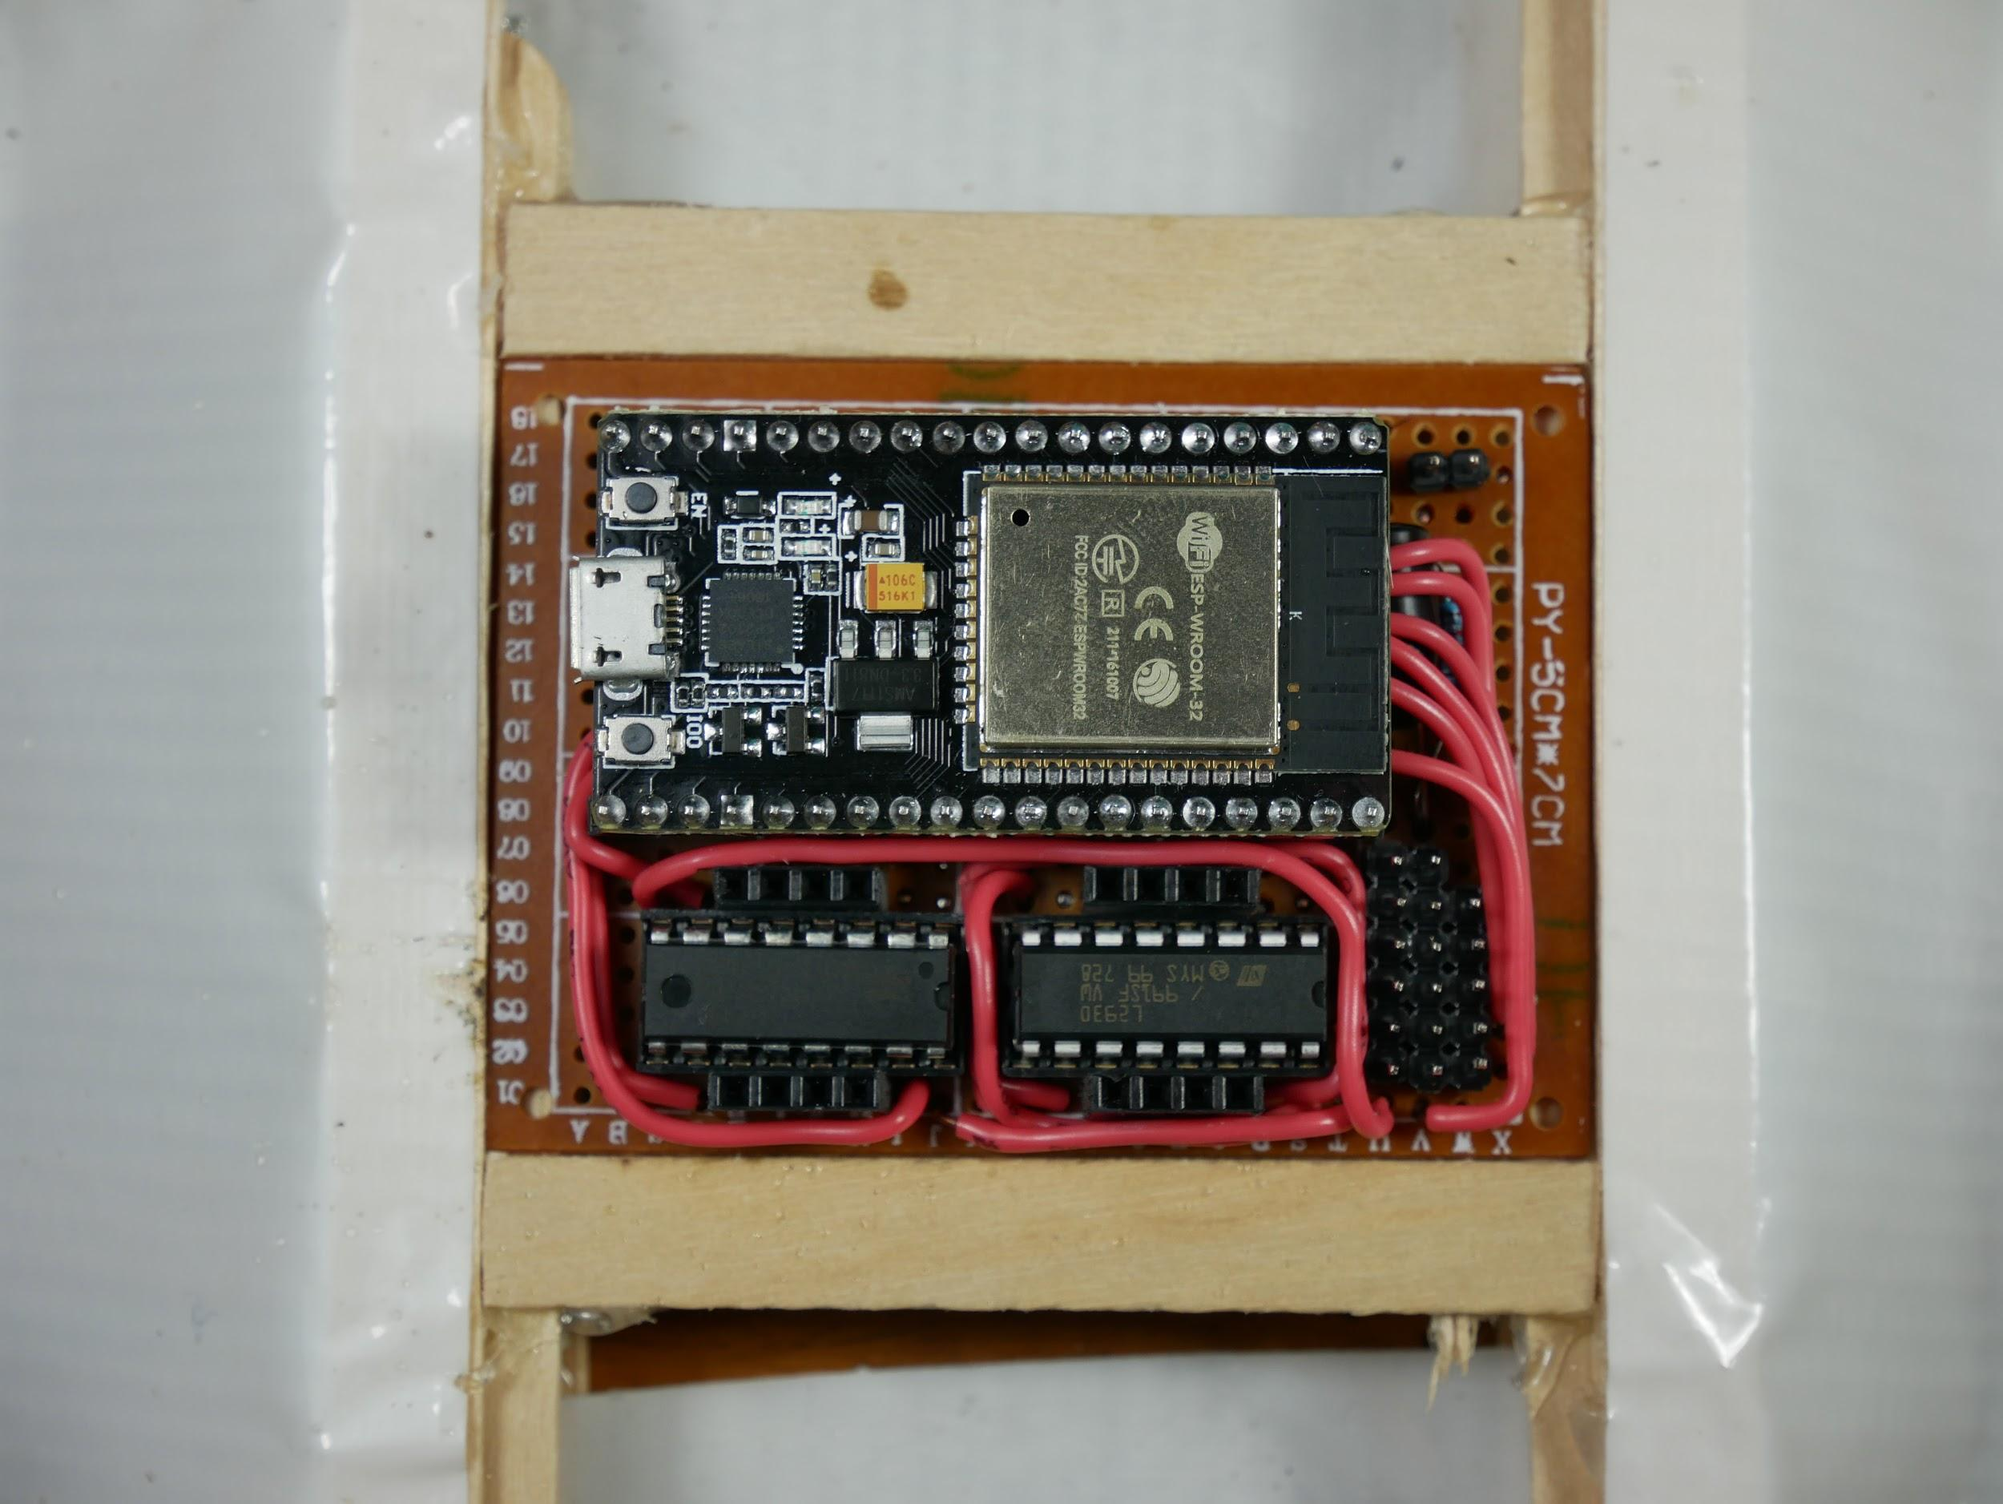

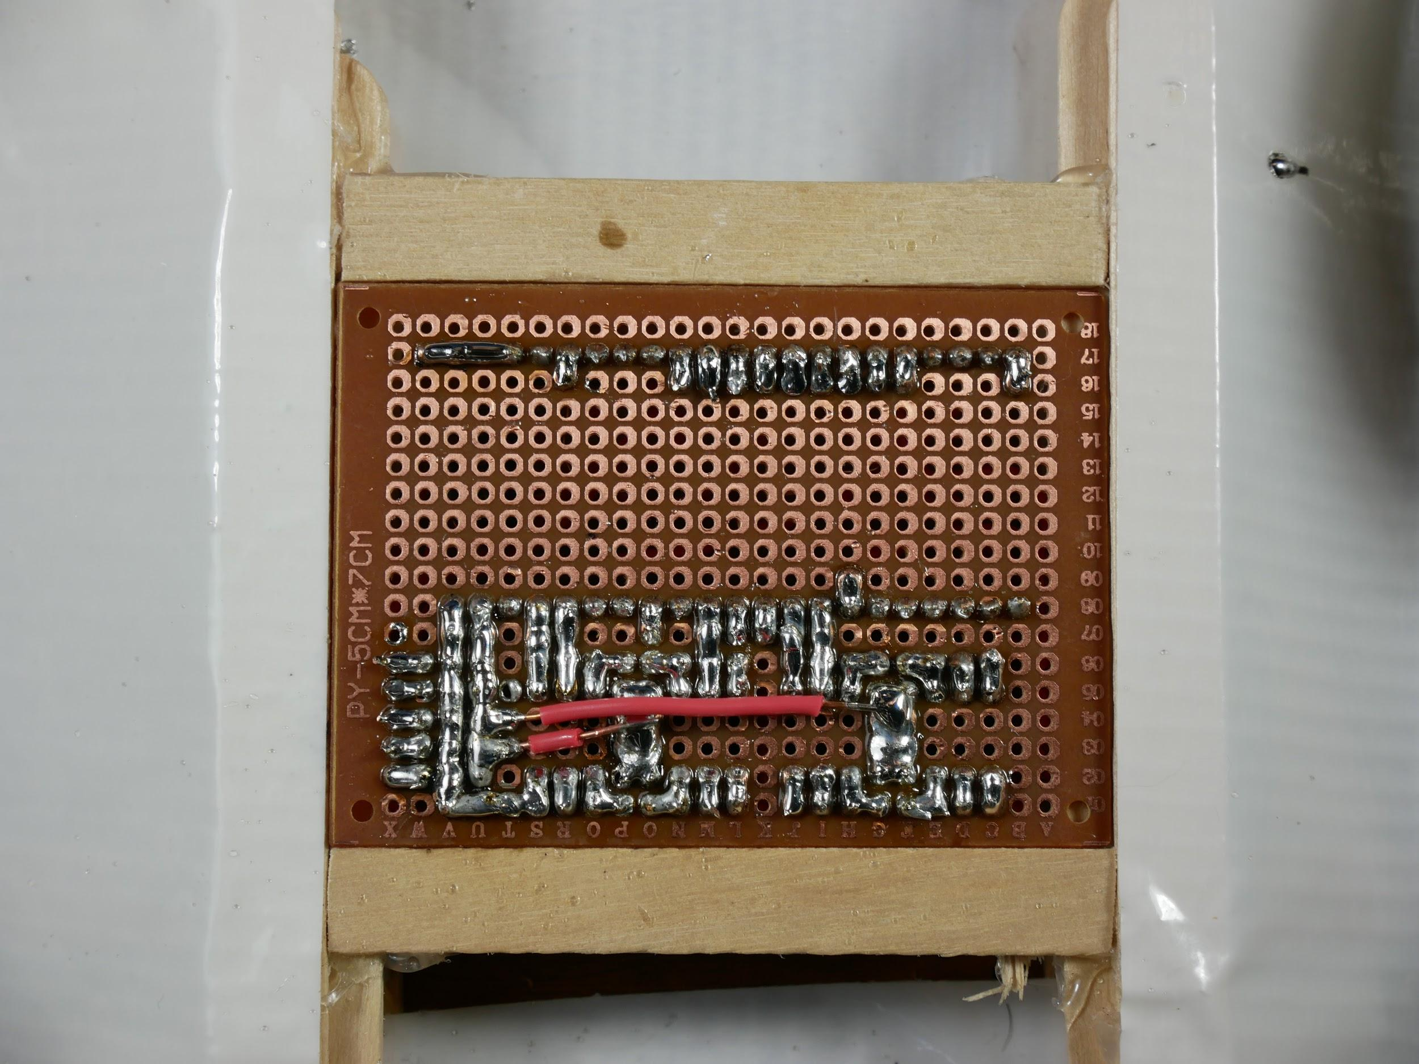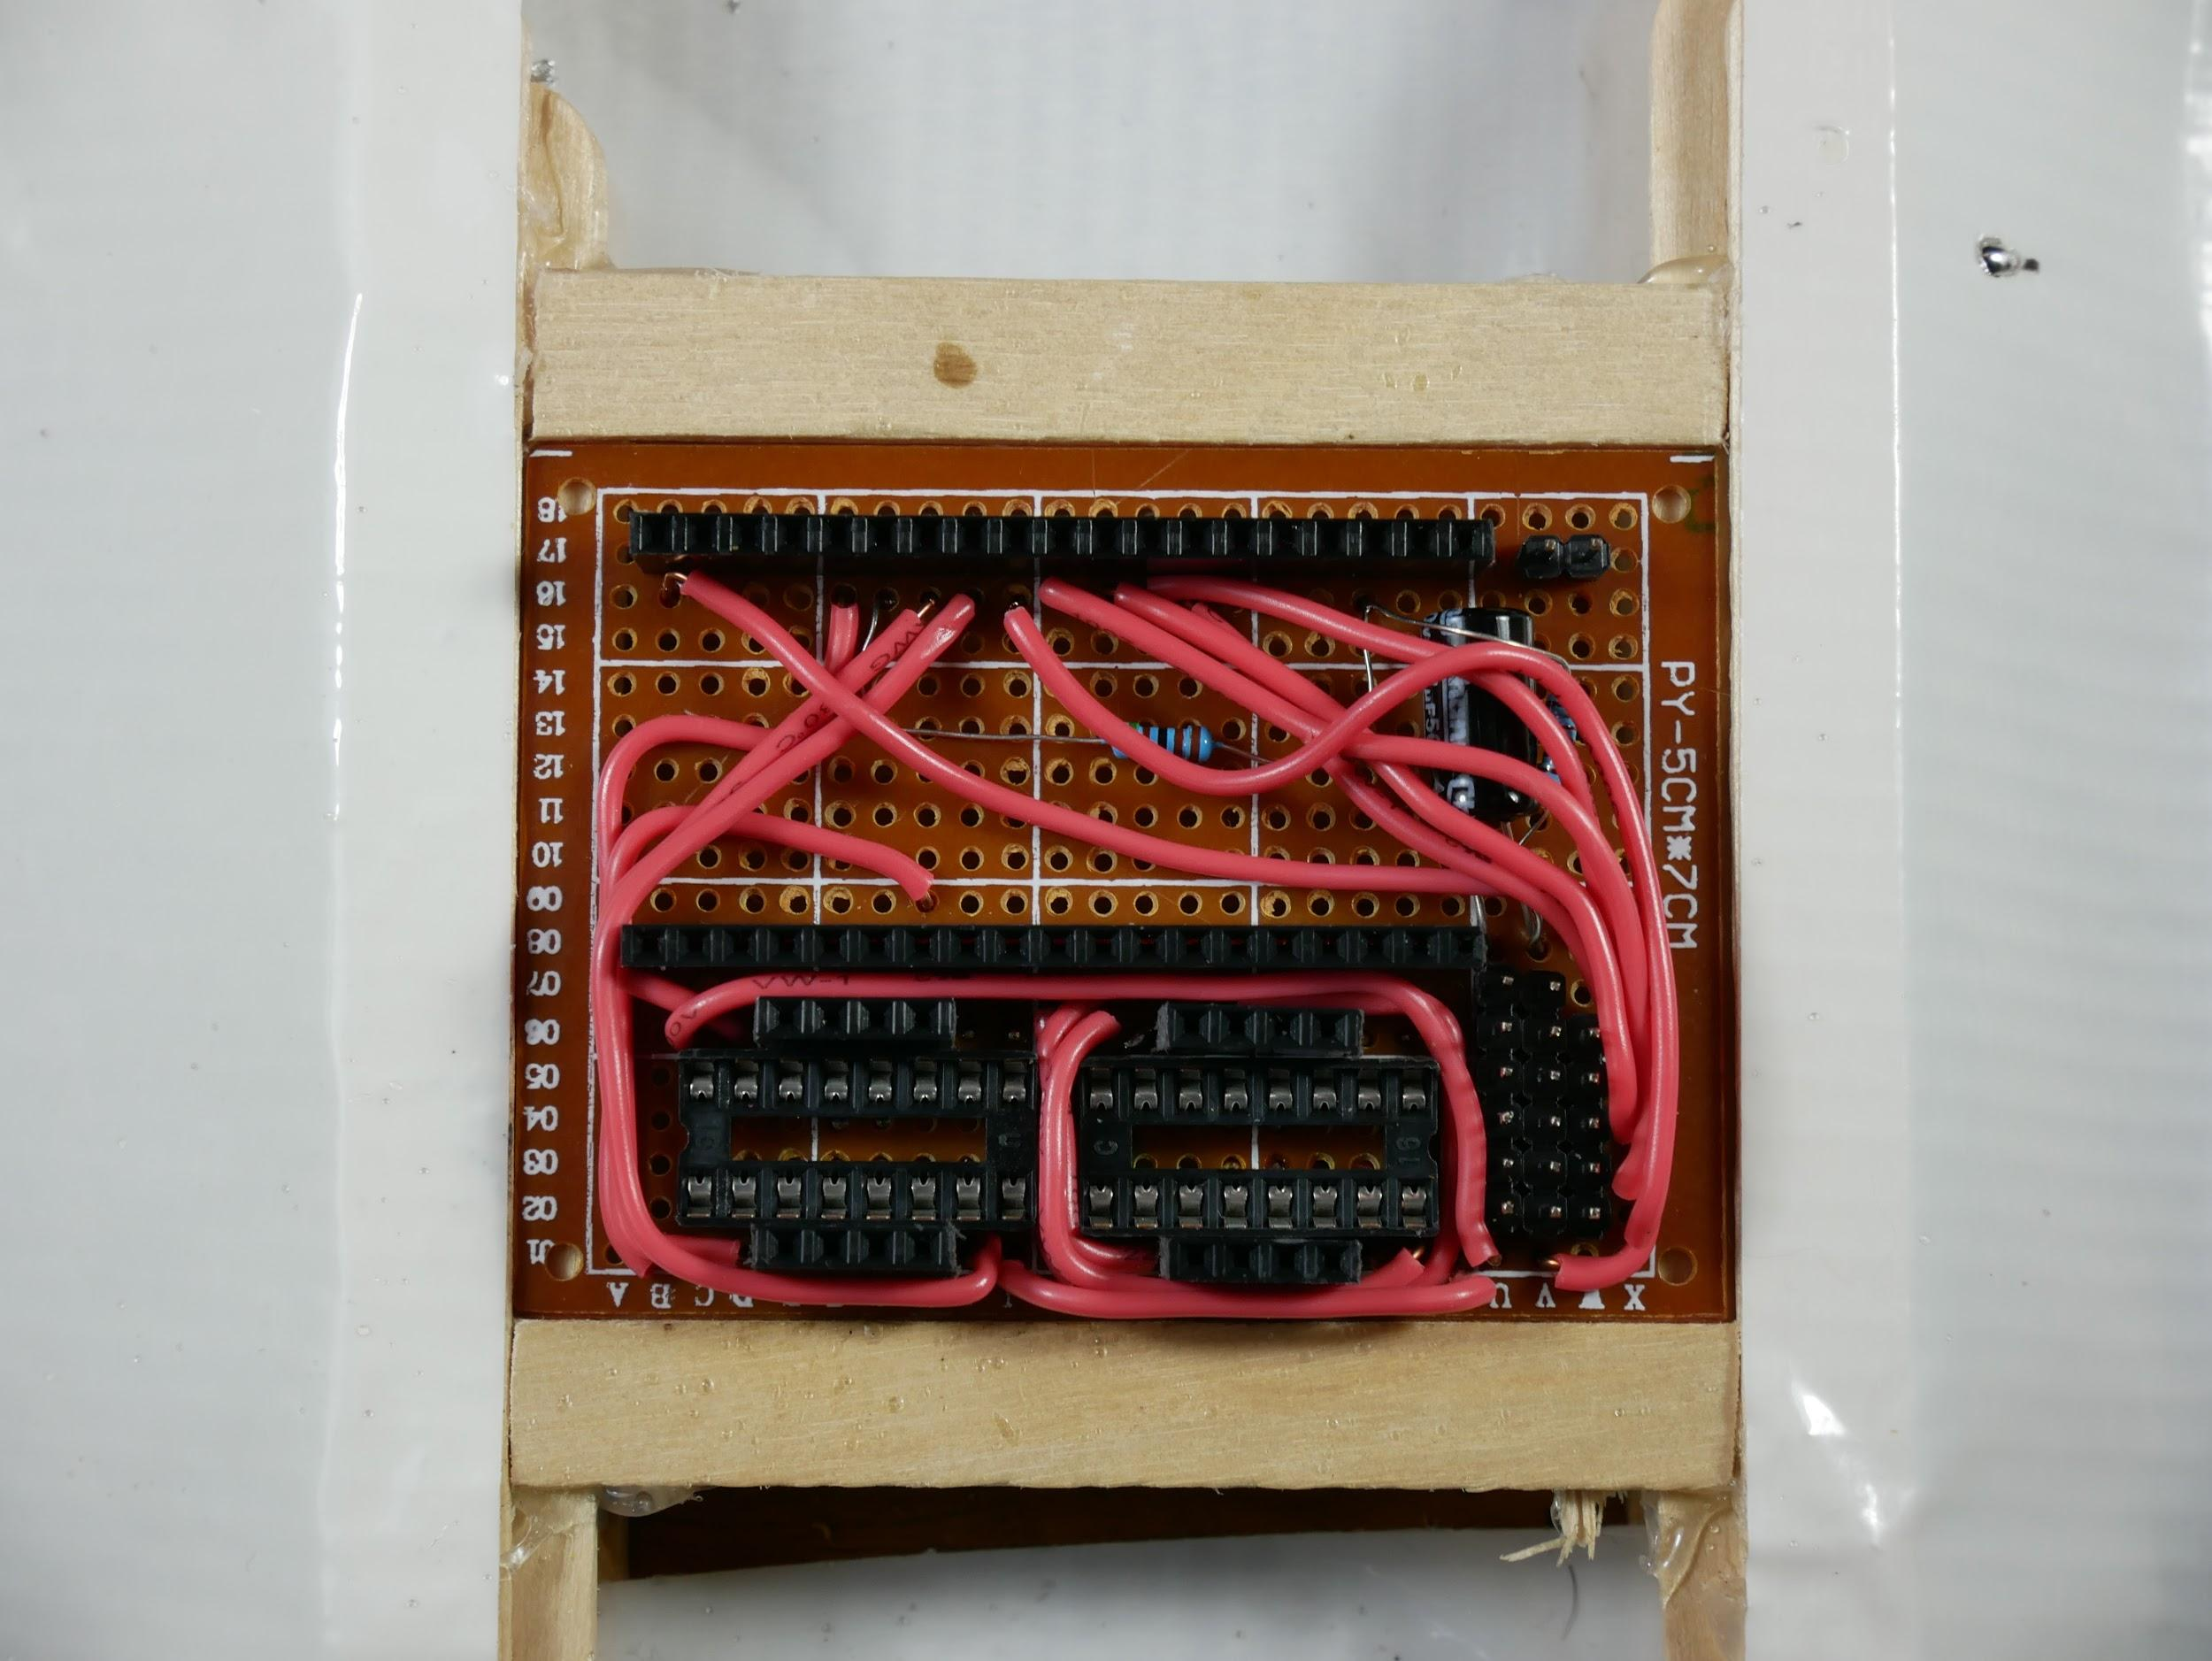

[Spreadsheet of circuit design.](https://docs.google.com/spreadsheets/d/1CU-nc-A7mxIIo_vOU9j2zoCkf-lnWo5c/edit?usp=sharing&ouid=103222519724452156319&rtpof=true&sd=true)

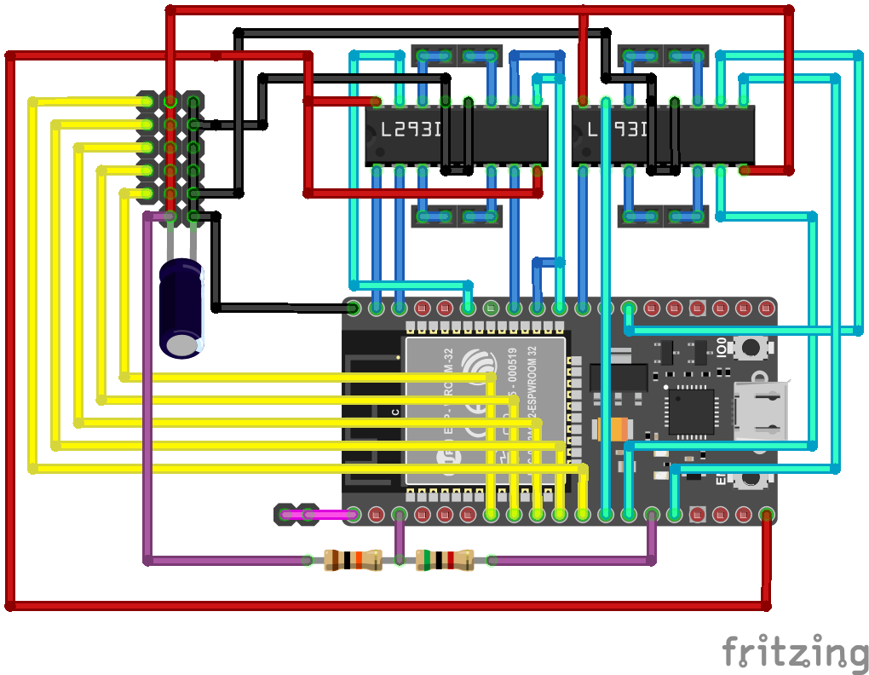

# Parts:

1 NodeMCU ESP-32s, it should have 38 pins

2 L293D motor driver chip

1 2x3 inch perf board with 18x24 holes

54 female header pins

19 male header pins

2 16 pin IC sockets

4ft wire (I used 22 gauge solid core)

1 5 AA bat holder

1 47uf capacitor

1 5 KΩ resistor

1 10 KΩ resistor

0-4 small 6v geared motors (<600 mA)

0-5 micro servo motors

5 rechargeable NiMH AA batteries

# Tools:

Soldering iron

Solder

Needle nose pliers

Wire strippers

Flush cutters

Sandpaper

Fume extractor fan

Tape

# Build:

## Add components

1. Notice the letter and number labels on the perf board. Orient the perfboard so 1 corresponds to the top row of holes, 18 corresponds to the bottom row, A corresponds to the right column and X corresponds to the left. This is the side components will be added from. Only add components to the side without metal around the holes, only solder to the side with metal around the holes.
2. *Use tape to secure each part to the board so it won’t fall out when you turn the board over to solder. Make sure everything stays at right angles to the board since if pins are soldered at an angle it will be hard to plug into them later.*
3. Cut two 19 pin strips of female headers and put them in the board so they fill holes 8B-8T and 17B-17T. Solder each pin to its hole.
4. Solder one 16 pin socket into holes 2C-2J and 5C-5J and solder the other socket into holes 2L-2S and 5L-5S.
5. Solder 1 strip of 5 male header pins in 2W-6W, and 2 strips of 6 male header pins in 2V-7V and 2U-7U.
6. Solder 4 strips of 4 female headers in the following holes: 1E-1H, 6E-6H, 1N-1Q, 6N-6Q.
7. Solder two male headers in holes 17V and 17W
8. Put the negative wire of the capacitor (marked with a grey stripe and the shorter of the two) in 8U. Put the other wire of the capacitor and one wire of the 10KΩ resistor in 8V. The capacitor’s leads should be long enough that it can be laid down on the board (~1cm), and the resistor’s wire should be about 2 cm. Solder the parts in.
9. Solder one wire of the 5KΩ resistor to 16G leaving the wire about 2 cm long.
10. Solder the free wires of the two resistors to 16R. *Make sure to not block the holes in row 16 with the resistor wire since other wires will need to connect there.*
11. Trim any long wires sticking out of the solder.

## Make connections

1. Flip the board to the component side.
2. *To connect two holes with a wire, cut a length of wire slightly longer than the distance between the two holes, strip about 2 mm of insulation off both ends, and put the ends in the holes. Try to route the wires nicely and remember that you’ll need to be able to access the plugs.*
3. Connect holes 1L and 7K with a wire.
4. Connect holes 1M and 7L with a wire.
5. Connect holes 1R and 7O with a wire.
6. Connect holes 1C and 16F with a wire.
7. Connect holes 1D and 9H with a wire.
8. Connect holes 6D and 16H with a wire.
9. Connect holes 1I and 16I with a wire.
10. Connect holes 1S and 6L with a wire.
11. Connect holes 1T and 1J with a wire.
12. Connect holes 1U and 6C with a wire.
13. Connect holes 1V and 16B with a wire.
14. Connect holes 6X and 16N with a wire.
15. Connect holes 5X and 16M with a wire.
16. Connect holes 4X and 16L with a wire.
17. Connect holes 3X and 16K with a wire.
18. Connect holes 2X and 16J with a wire.
19. Flip the board over to the back side and solder all the wires in.
20. *To connect holes over shorter distances, blob solder between them.*
21. Connect holes 1C and 2C by bridging them with solder.
22. Connect holes 1D and 2D by bridging them with solder.
23. Connect holes 1I and 2I by bridging them with solder.
24. Connect holes 1J and 2J by bridging them with solder.
25. Connect holes 5C and 6C by bridging them with solder.
26. Connect holes 5D and 6D by bridging them with solder.
27. Connect holes 1L and 2L by bridging them with solder.
28. Connect holes 1M and 2M by bridging them with solder.
29. Connect holes 1R and 2R by bridging them with solder.
30. Connect holes 5L and 6L by bridging them with solder.
31. Connect holes 8H and 9H by bridging them with solder.
32. Connect holes 7K and 8K by bridging them with solder.
33. Connect holes 7L and 8L by bridging them with solder.
34. Connect holes 7O and 8O by bridging them with solder.
35. Connect holes 16B and 17B by bridging them with solder.
36. Connect holes 16F and 17F by bridging them with solder.
37. Connect holes 16G and 17G by bridging them with solder.
38. Connect holes 16H and 17H by bridging them with solder.
39. Connect holes 16I and 17I by bridging them with solder.
40. Connect holes 16J and 17J by bridging them with solder.
41. Connect holes 16K and 17K by bridging them with solder.
42. Connect holes 16L and 17L by bridging them with solder.
43. Connect holes 16M and 17M by bridging them with solder.
44. Connect holes 16N and 17N by bridging them with solder.
45. Connect holes 16R and 17R by bridging them with solder.
46. Connect holes 2W and 2X by bridging them with solder.
47. Connect holes 3W and 3X by bridging them with solder.
48. Connect holes 4W and 4X by bridging them with solder.
49. Connect holes 5W and 5X by bridging them with solder.
50. Connect holes 6W and 6X by bridging them with solder.
51. Connect holes 1E, 2E, and 1F by bridging them with solder.
52. Connect holes 1H, 2H, and 1G by bridging them with solder.
53. Connect holes 5E, 6E, and 6F by bridging them with solder.
54. Connect holes 5H, 6H, and 6G by bridging them with solder.
55. Connect holes 1N, 2N, and 1O by bridging them with solder.
56. Connect holes 1Q, 2Q, and 1P by bridging them with solder.
57. Connect holes 5N, 6N, and 6O by bridging them with solder.
58. Connect holes 5Q, 6Q, and 6P by bridging them with solder.
59. Connect holes 5I-8I by bridging them with solder.
60. Connect holes 5J-8J by bridging them with solder.
61. Connect holes 5M-8M by bridging them with solder.
62. Connect holes 5R-8R by bridging them with solder.
63. Connect holes 5S-8S by bridging them with solder.
64. Connect holes 1V-8V and 1S-1U and 2S by bridging them all with solder.
65. Connect holes 2U-8U, and 8T by bridging them all together with solder.
66. Connect holes 17T-17W by bridging them with solder.
67. Connect holes 2O-5P by bridging them with solder.
68. Connect a wire from 3T to this blob, and also bridge 3T over to 3U (don’t stick the wire in the hole all the way up to the insulation).
69. Connect holes 2F-5G by bridging them with solder.
70. Connect a wire from 4T to this blob, and also bridge 4T over to 4U.
71. Plug the esp32 into the long header strips, so the usb port faces right.
72. Plug the two l293d chips into their sockets, rotation doesn’t matter.

Optional extra 3 input pins

Put 3 male headers in 18O-18Q and bridge each pin to the neighboring pin on row 17.

Viewing the board from the front side, the headers connect to esp32 pins 39, 34, 35 with 35 the closest to the usb port. *These pins on the esp32 can only function as inputs*!

**Power Switch and batteries**

Add female pins to the battery pack wires.

Solder solid core wire or male headers to the motors so they can be plugged in.

# Programming and Testing:

[**RCM user guide**](https://drive.google.com/open?id=12HUcpWKluF6-3oLMwZiLKZ4KrxwmTE_D)

## Upload Code to RCM:

<https://github.com/rcmgames/rcm>

## Install Driver Station App:

<https://github.com/rcmgames/RCMDS>

<https://github.com/rcmgames/RCMDS-new>